Part 1:

Question 1:

Question 2:

Question 3:

Question 4 :

Question 5:

Question 6:

|  |  |
| --- | --- |
| A picture containing text  Description automatically generated  Calculated Vin Value =0.6301 | A screenshot of a computer  Description automatically generated with medium confidence  Simulated Vin Value =0.6301 |

Question 7:

Question 8:

Part 2:

Question 1:

Before Lock

After Lock

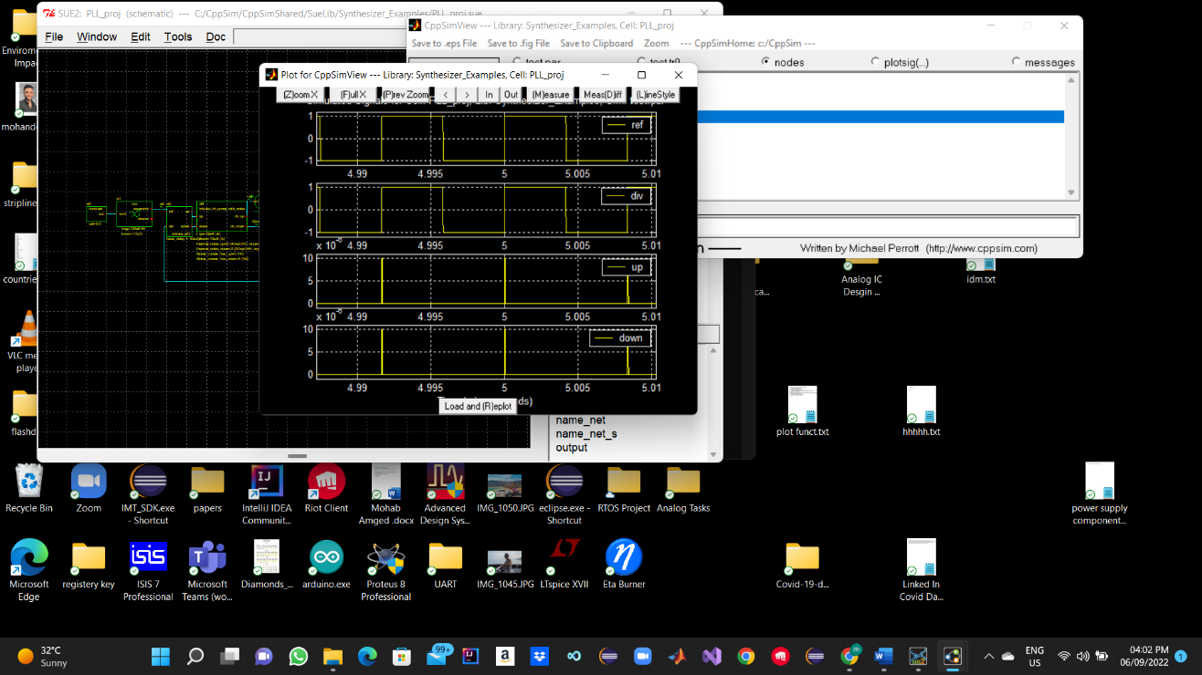

Question 2:

Before Lock

After Lock

